**Host Your React Website From GitHub**

Grizli777 | [Company address]

Host react Website From Github

Pokesh Kumar

[Year]

**Host your React website from GitHub Follow These Steps**

1.step

* Go to the React App from visual studio and open the react app terminal
* Then type these command

**npm Install gh-pages –save-dev**

2.Step

* Now go to the github and then create a new repository

2.step

* Now come to the visual studio code then open the react app file location
* And open the react app terminal then type all the command that git provide the git repository

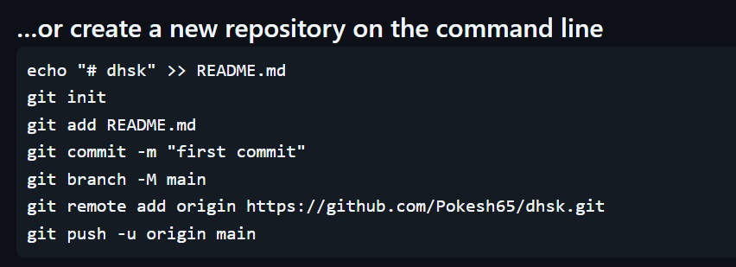

Like this command git will provide you and follow these command and run all command on your git react app terminal

4.step

* Now go to the github website then refresh the github page,after refresh all your react app code will be available on git

5.step

* Then go to the visual studio react app and open package.json file then type this inside the package.json

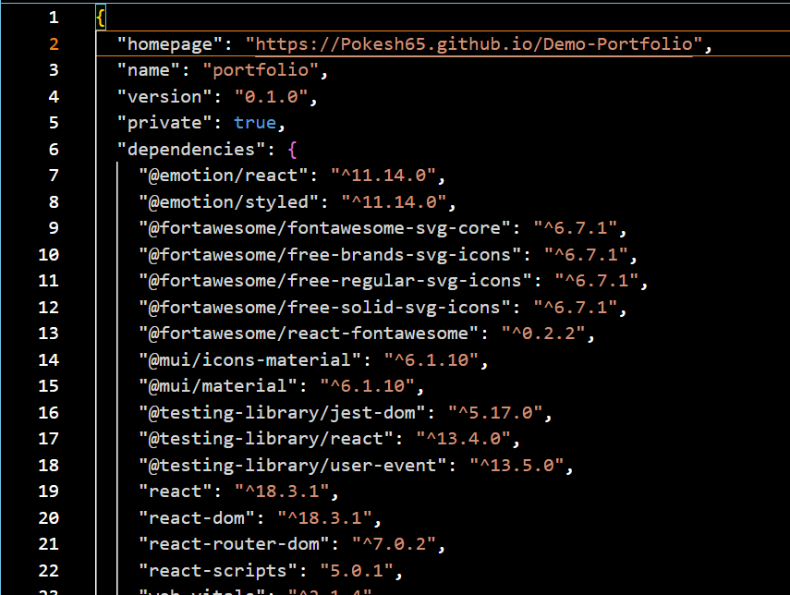



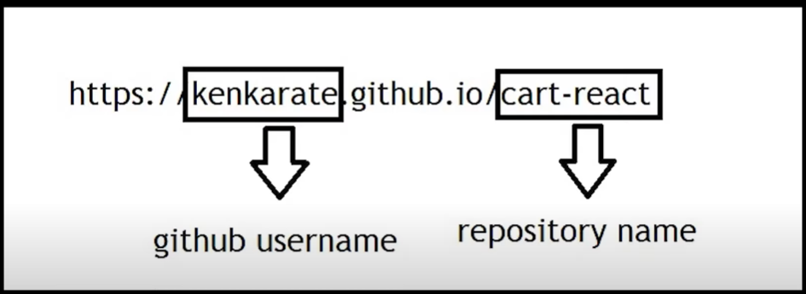

* Inside the package.json go to the script then type these

**“predeploy”:”npm run build”,**

**“deploy”:”gh-pages -d build”**

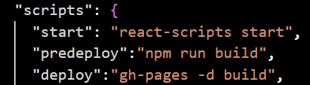

6.step

* now go to the react app and open the terminal and run this command

**npm run deploy**

7.step

* Now go to the github then open the repository that you created and then **settings->on the setting go to the->pages** after a few seconds you will see the deployed link of your website on the github

